Now open: Artroots Grants for PfE projects – up to £6000!

Sustrans Scotland’s 2023/2024 Places for Everyone (PfE) ArtRoots grant is now open, and we would love you to consider applying.

ArtRoots, supported by funding from the Scottish Government through Sustrans, works in partnership with local community groups to make artistic and aesthetic improvements in conjunction with PfE infrastructure projects in Scotland.
Do you have a PfE infrastructure project that could benefit from some artistic input?

- Think about your project, is it community-led?
- Are you a community organisation? To process an application we would need to see: 1. A signed constitution and 2. the required number of board members in accordance with your constitution.
- Do you think that the inclusion of an artwork could help the local community to become more interested in the project?
- Will an artwork such as a mural, sculpture or decorative seating for example encourage your local community to walk, wheel or cycle along your new path?
What is ArtRoots?

ArtRoots offers up to £6000 to enable communities to shape their local environment by making Places for Everyone projects more attractive and accessible for everyone. Community-led art projects enhance neighbourhoods and encourage more people to explore their local areas by walking, wheeling and cycling.
The fund supports local enterprise, talent, and culture by backing projects identified through local consultation and community engagement.

- How much money is available? The standard grant awarded for an ArtRoots project is £2,500. Awards up to £6000 are available for projects which can demonstrate that a higher amount will significantly increase new walking, wheeling and cycling journeys.
- Who can apply? Community groups, social enterprises, and other organisations involved in local community engagement activities– please get in touch if you need further information.
- Local Authorities are unfortunately not eligible, however, they could invite a community group to take ownership of artwork within a local authority infrastructure project by encouraging, supporting and endorsing a community partner to apply.

Interested parties can find application guidelines and how to express an interest by visiting the Sustrans Showcase website URL here

The 2023/24 funding round will close on 1st December 2023.

Applicants can receive funding for: sculptures and artworks, installations, events, performances, and much more.

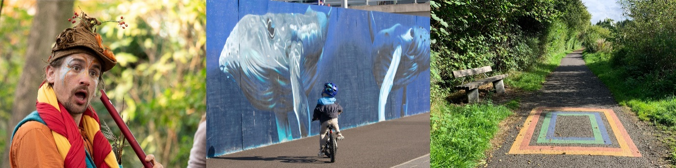
Examples of previous successful ArtRoots grants along the National Cycle Network routes in Scotland include:

- Positive Imagining: community-led Positive Imaginings performed children's climate circus along National Cycle Network Route 1 in Craigmillar, Edinburgh.
- Dundee Waterfront Mural: community council-led project that revitalised Dundee Waterfront with colourful murals.
- Aberfoyle Art Trail: community engagement project with resident pupils delivered colourful stencil art along local National Cycle Network paths surfaces.
Sustrans support for communities

Sustrans works for and with communities, helping them to create healthier places and happier lives for everyone by making it easier for people to walk, wheel and cycle in their local area.
We inspire people to change the way people travel every day, forging closer connections with our neighbours and reducing traffic to create a better environment and a more sustainable society for everyone.
We are custodians of the National Cycle Network, a UK-wide network of traffic-free paths for everyone, connecting cities, towns, and countryside, loved by the communities they serve.
Find out about other opportunities, advice, support, and funding work in Scotland.

If you have any further queries about ArtRoots, or the application process, email Sustrans ArtRoots Project Officer, Kasia Jackowska
please also CC: Caroline.Austin@sustrans.org.uk

If you have any queries on the partner pack or cannot access the resource, email Sustrans Communications Officer, Elisa Paolucci.

Thanks for your time,

