Spaces for People -
Route Map to Permanence
Introduction
Spaces for People was designed to respond to the public health emergency by creating space to enable people to safely physically distance. Measures have included temporary 20mph speed limits, pop-up cycle tracks, road closures and footway widening. Where these interventions have been deemed “successful” there may be appetite to make them permanent in order to continue to support journeys being made by active travel. This document will set out the process, risks and opportunities to create a ‘route map to permanence’. Where appropriate and with due process, including taking account of the implications for disabled people, local authorities therefore have the ability to consider options for turning temporary infrastructure into permanent in the medium to longer term.
What does permanent look like?
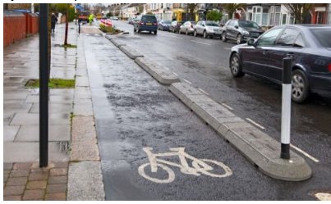
Permanent infrastructure may look the same or very similar to some of the temporary interventions we have seen throughout Scotland. The main difference may only be the underlying legal traffic order. For example, the use of bolt down rubber kerbs, cycle lane defenders or orcas may all be used for a permanent scheme. Similarly, 20mph schemes, which are already signed and lined, may only need the traffic order to become permanent rather than any further physical works.
In other cases, such as footway widening projects, it may only be feasible and sustainable to make these permanent through full permanent construction.
Things to consider when making interventions permanent
- Was the intervention successful?
  - What positive and negative effects have there been on walking, wheeling, cycling, business, public transport, disabled people etc.?
  - Does it encourage more people to walk, wheel and cycle?
  - Is there an evidence base?
- Is there public and political support?
- Traffic Regulation Orders
- Funding
- Decision making
- Maintenance
- Is it part of a coherent and/or strategic walking, wheeling and cycling network or a standalone opportunity taken during the pandemic?
Actions when making interventions permanent
- Update or undertake a project specific Equality Impact Assessment
- Carry out meaningful engagement and consultation
- Review the design to adapt or improve it
- Complete a Road Safety Audit
- Carry out physical works (as required)
- Start the TRO process (if an Order was required for the Spaces for People project)
The flow chart linked below sets out a process for making a temporary interventions permanent:
https://www.showcase-sustrans.org.uk/wp-content/uploads/2020/06/Flochart-3b.pdf
Ultimately, a decision will be needed at a local level on whether the temporary interventions will be made permanent. Such decisions are predominantly made by local authorities. There will therefore be a need to use the evidence from the above steps to support recommendations and inform politicians.
Traffic Regulation Order
Where an order has been required in Spaces for People, partners have used the Temporary Traffic Regulation Order (TTRO). This follows Scottish Government guidance on using Temporary Traffic Regulation Orders and notices in Scotland during the period public health measures are in place to reduce transmission of coronavirus (COVID 19).These can be used to restrict traffic and create additional space for safe social distancing in order to avoid danger to the public.To make any interventions permanent, partners require a Traffic Regulation Order (TRO). The normal TRO processes should be followed by each local authority as there is currently no other mechanisms available in Scotland to make interventions permanent. If you are planning on making any SfP intervention permanent, the TRO process should begin as soon as possible.
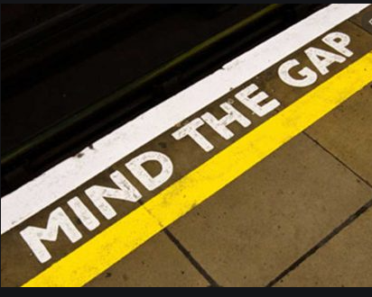
Mind the Gap – there should ideally not be a period between a TTRO expiring and a TRO becoming live. These orders will need to overlap otherwise an intervention may have to be removed or ‘bagged’ when the TTRO expires and reintroduced when the TRO is live. This could result in confusion for road users, which may undermine the support for and benefits from the interventions. Clear communication on making any interventions permanent will be essential, which is likely to go beyond the normal notices for a TRO.
Further options:
- Partners can apply for an extension of the TTRO through Transport Scotland if you are in the process of making the intervention permanent. This will only be feasible where the current health emergency exists.
- Partners may be able to use Experimental Traffic Regulation Orders to retain SfP interventions in order to formally trial and gather evidence on the interventions prior to making them permanent.
- If material objections are received on a TRO, Transport Scotland may be able to expedite the decision making process.
Funding
Your remaining Spaces for People budget can be used to make temporary interventions permanent. However, this will have to be within your current allocation and meet the conditions set out by Sustrans. Furthermore, if you are not going to spend your full allocation then please contact Sustrans.
Funding returned to Sustrans is intended to be reallocated back into Places for Everyone. Return of SfP funding will not be considered as a factor when future applications for any of Sustrans’ funding programmes are assessed. Cycling Walking Safer Routes funding from Transport Scotland may also be used to make these interventions permanent, as these are likely to meet the fund’s active travel objectives.
Alternatively, some interventions may already link or overlap with existing Places for Everyone projects and in this case, funding could be sourced through existing projects. Please contact Sustrans if you would like to discuss this further.
As per all Places for Everyone funded projects, partners should also consider the costs for long-term maintenance and renewal of the intervention, which are considered likely to fall on existing budget provisions.
Support
Sustrans will continue to facilitate knowledge sharing and peer to peer learning sessions.
Sustrans can support in undertaking a design review to assess whether the temporary interventions need to be altered in order to become permanent. This could include updating the EqIA, which in making permanent has even greater importance, site visits (restrictions permitting) and drawing production. Sustrans may also be able to provide support for school specific interventions.
Please get in touch with Sustrans if you would like further information.
Version Control
Version  2  Document title over one line, maximum 10 words text text  00 Month 2019  3  Document title over one line, maximum 15 words text text text text text  00 Month 2019  4  Document title over one line, maximum 10 words text text  00 Month 2019  5  Document title over one line, maximum 15 words text text text text text  00 Month 2019  6  Document title over one line, maximum 10 words text text  00 Month 2019  7  Document title over one line, maximum 15 words text text text text text  00 Month 2019 | Date | Author | Changes
1.0 | 22/02/2021 | M. Melton | Initial Version

