Covid-adapted School Travel Measures

01 June 2020
To find out more, please contact:
Sustrans is the charity making it easier for people to walk and cycle.
We connect people and places, create liveable neighbourhoods, transform the school run and deliver a happier, healthier commute.
Join us on our journey.
www.sustrans.org.uk
Registered Charity No. 326550 (England and Wales) SC039263 (Scotland).

Overview
This document is for use by local authority roads/ school travel team and schools to create a plan for supporting physically-distanced active school travel.

It can be used to identify measures which will support public health through increasing space and safety for walking, cycling and wheeling, reducing traffic, lowering speeds and encouraging active travel.

If your area has an I Bike officer, they will be able to support with the creation of a temporary measures plan for priority schools as well as implementation of measures in the school where needed.
School details
High School/ Primary School/ Nursery: Click here to enter text.

Current Hub School: Choose an item.

Headteacher name: Click here to enter text.

Pupil roll:Click here to enter text.
Things to consider

- Is your school a SIMD/KSI priority area?

- What is the local data on collisions in last five years and how can this inform your temporary measures plan?

- What are your scooter and cycle parking needs?

Notes:

Review of catchment area
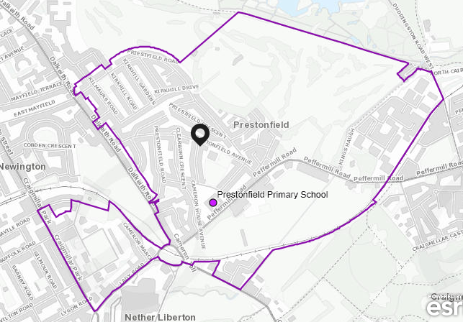
Include an image of your catchment area in your plan, like this:

Catchment area

Detail here how the school catchment area can impact on pupils and staff ability to travel actively to school by considering:

- Size of catchment
- How feasible is active travel to school for pupils? For example currently the whole catchment is under X minutes walking time.
- What are the current major barriers to active travel?
- Has the school had prior issues with pavement parking/ dangerous crossings etc?
- Level of bus usage
- Current access to school in grounds and immediate surroundings
Notes:

Design of school/entrances

Include possible measures that could be implemented at school entrances that will improve the ability of people to practice physical distancing, when dropping off and collecting children.

For example:

- Allocating entrances as exit or entrance only
- Utilising vehicle access gates differently
- Use temporary bollards or planters to cordon off road space to make more pedestrian space around gates
Here’s an example of how gate use can be changed, to enable physical distancing when entering and leaving school:
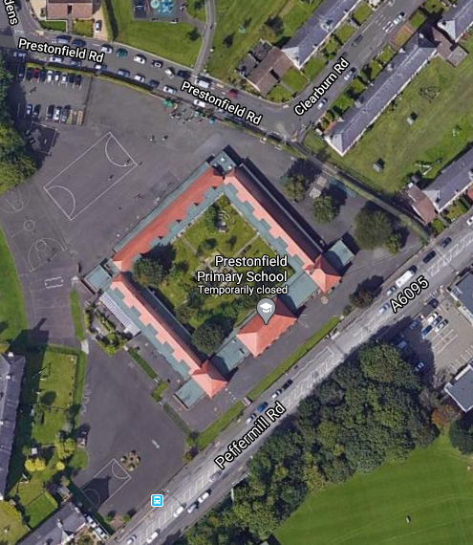
Vehicle access gate
Two narrow gate entrances with steps up to school yard
Two narrow gate entrances with steps down into school yard

On Peffermill Road, the entrances to school should be a one-way system.
.
Notes:

Suggested drop-off and collection plan

Consider ways to encourage physical distancing through influencing parent travel behavior, such as:

- Designated locations for park and stride model for dropping off children to enable safe distancing
- Deterrents to discourage people from parking outside the school gates eg bollards, planters, line markings
- Potential for closing whole streets outside the school (variations on ‘School Streets’ models)
- Active travel promotion including parents guidance leaflets, school guidance leaflets and signposting to information
Notes:

Reduction of Speed

Consider measures that can be introduced outside the school/ on major routes, such as:

- Implementing speed limits
- Implementing road measures such as temporary raised tables or painting of surfaces
Notes:

Park and stride maps (if applicable)

Consider here:

- Marking area(s) for parking away from the school
- Making sure suggested connecting route caters for increase in walking. For example widening pavements.

Notes:

Walking, cycling and scooting routes

Detail here how main routes in to school can be improved, and identify any major barriers (ie busy road crossings) to active travel, considering the points below:

- Measures to reduce parking – eg barriers, yellow lines
- Reallocating road space to increase pavement size
- Making roads into a one-way system to be able to implement increased pavement size and reduced road space (and make it less desirable to drive)
- Reducing speeds on key routes in to school
- Removal of barriers between pavement and road
- Implementing new crossing points
- consideration of current crossings and crossing patrol resource
Notes:

